**HCL BANK APPLICATION**

* The bank application consists of three users

1. Admin
2. Manager
3. Clerk

* **Users and roles:**

1. **Admin**

Among all users, Admin can perform all actions like creating new account, view all accounts and users and update and delete an account.

1. **Manager**

Manager can perform some actions like transfer, deposit and withdraw.

1. **Clerk**

Clerk can perform only limited actions like transaction history.

* **Actions:**

**Login:** This is used to login particular person. If login fails, then it redirects to home page.

**Add Account:** This can be done only by admin. The parameters are id, name, password, Address, phone number, email, Aadhar card, PAN card.

**Add User:** This is used to create a new account by admin. The parameter used here are id, name, password, Address, phone number, email.

**Show All Accounts:** Displays all accounts in database.

**Update Account:** This is used to update some of the details like phone number, email and address.

**Delete Account:** Used to delete Account.

**Transfer:** To transfer money from one account to another account.

**Deposit:** To deposit money to an account using Account id and amount to deposit.

**Withdraw:** To withdraw money from an account using account id and required amount to withdrawn.

t**ransaction Log:** Shows the transaction details.

Login page:

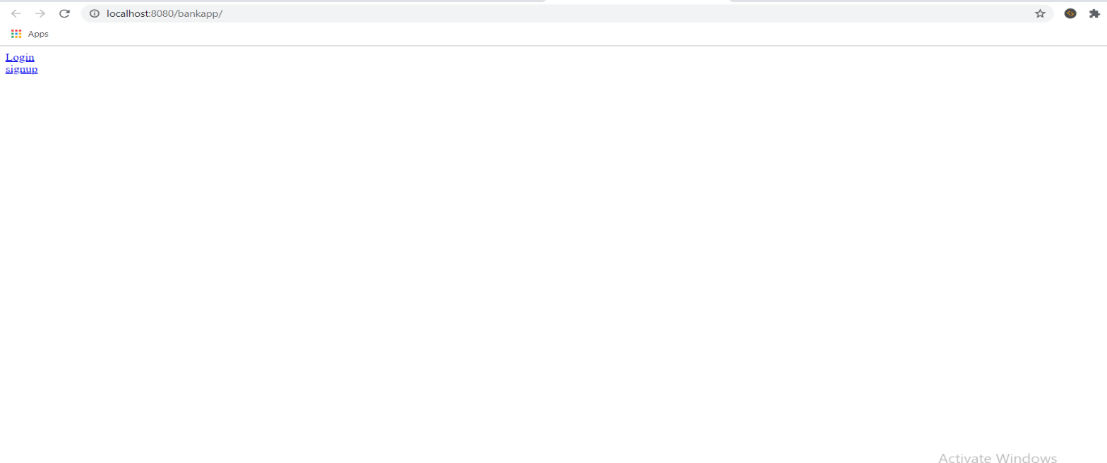

**Welcome page:**

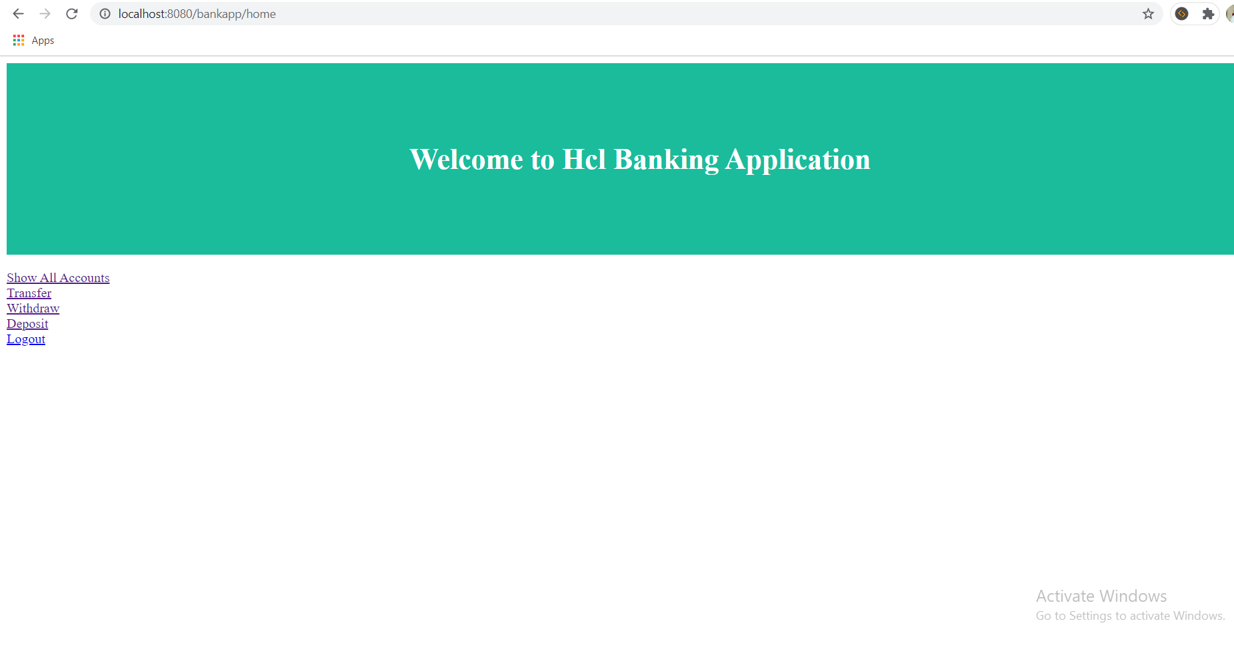

**Add account:**

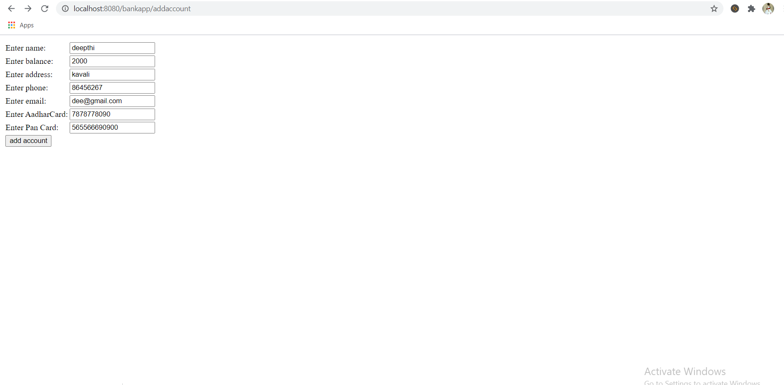

**Users Details:**

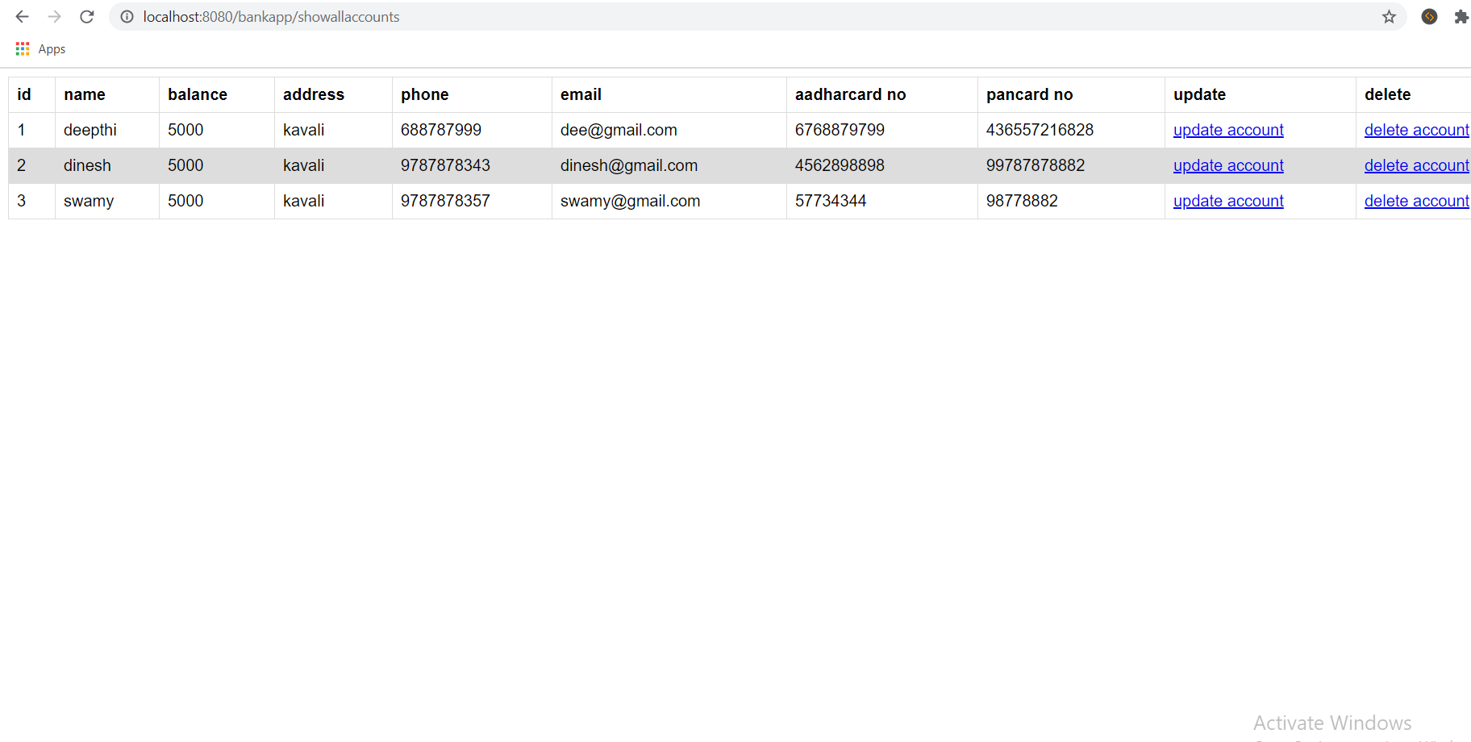

**Money Transfer:**

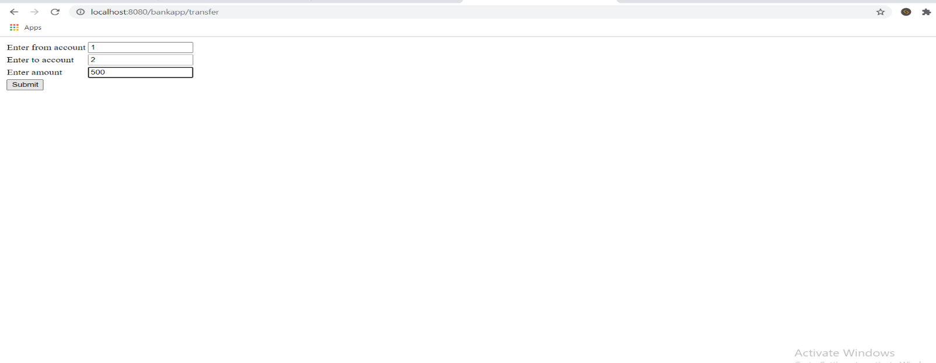

**Output of transfer page:**



**Detail after Transfer of money:**

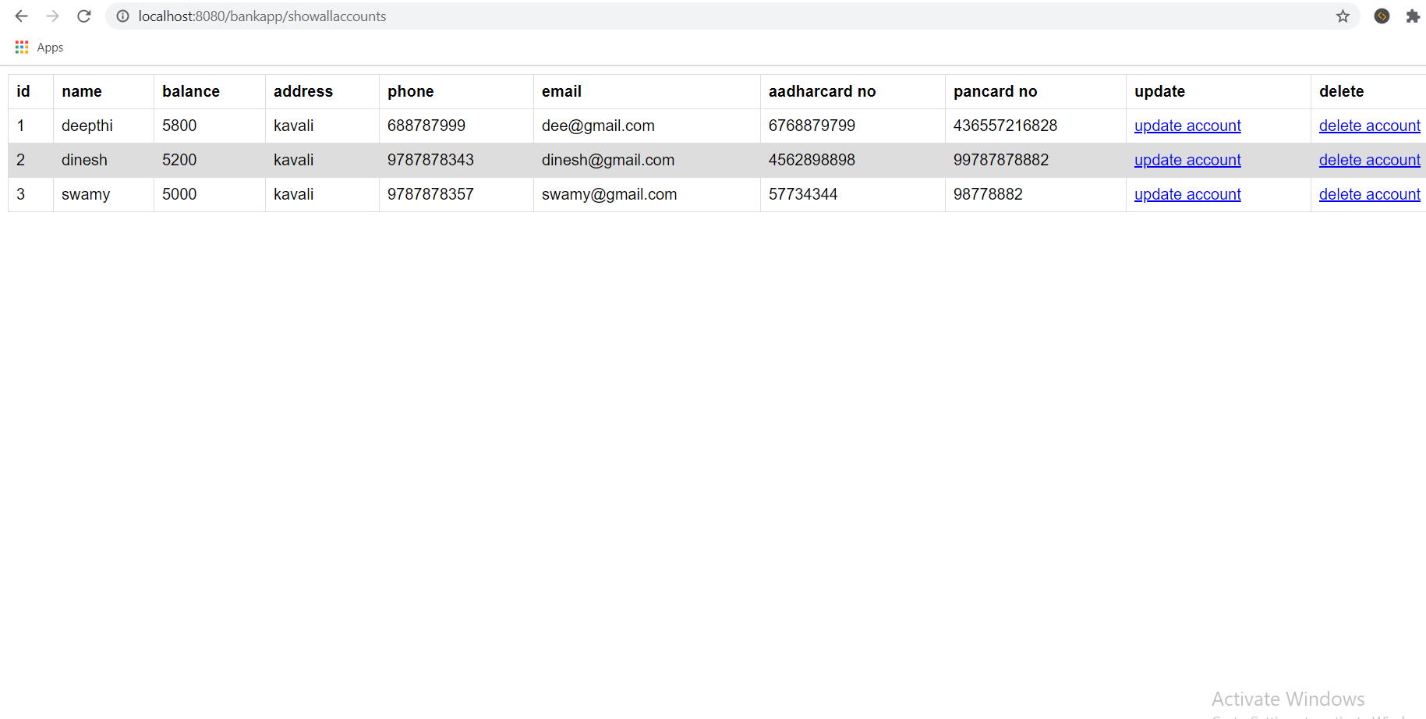

**Withdraw:**

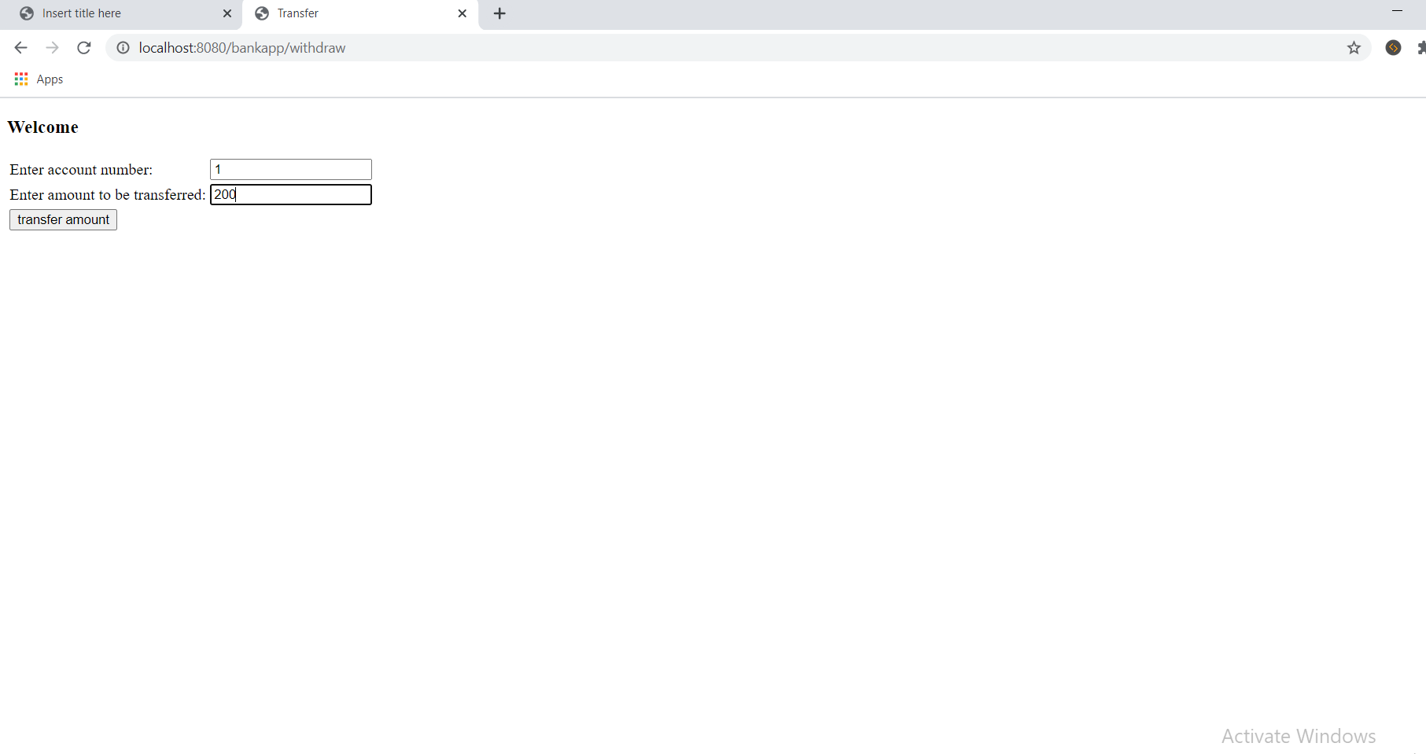

**Deposit Page:**

